**CASE STUDY ON PROCESS CAPABILITY OF GRINDING MACHINE**

Process capability uses capability indices to compare an “in-control” process output to the specification's upper and lower bounds. The spread of the process values, as measured by six process standard deviation units, is compared to the spread between the process requirements. A capable process is one where practically all measurements are within the allowable limits.

Process Capability is given by: (For 3σ Production Process)

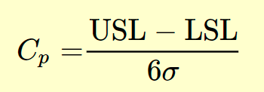

Process Capability Index is given by: (For 3σ Production Process)

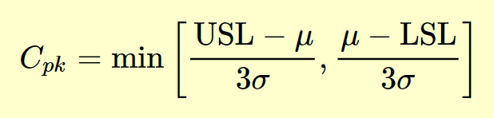

*POINTS TO NOTE REGARDING C*pk:

*C*pk measures how close a process is performing compared to its specification limits and accounting for the natural variability of the process.

The larger *C*pk is, the less likely it is that any item will be outside the specification limits.

When *C*pk is negative it means that a process will produce output that is outside the customer specification limits.

When the mean of the process is outside the customer specification limits, the value of *C*pk will be Negative.

Generally, a *C*pk of at least 1.33 [4 sigma] or higher will satisfy most of the customers.

**Understanding the parameters given:**

fHβ= Angle Error/ Angle Deviation.

ffβ= Form Error; Form errors are deviations of the machined surface from the geometrical surface excluding position errors, waviness and roughness.

Cβ= Crowning; the term "crowning" refers to the process of adding an appropriate amount of bulge to the direction of the tooth flank of the gear teeth.

Crowning is a type of modification of the tooth flank in which the tooth thickness at both ends of the tooth is gradually reduced from the center to prevent single tooth contact at the ends of a gear tooth due to manufacturing or assembly errors in the gear or shaft, and to concentrate tooth contact near the center of the tooth width. This will ultimately reduce the noise and extend the life of the teeth.

However, if the crowning is larger than necessary, the tooth contact area becomes too small, which may negatively affect the strength of the tooth.

**Parameters and Given Tolerances:**

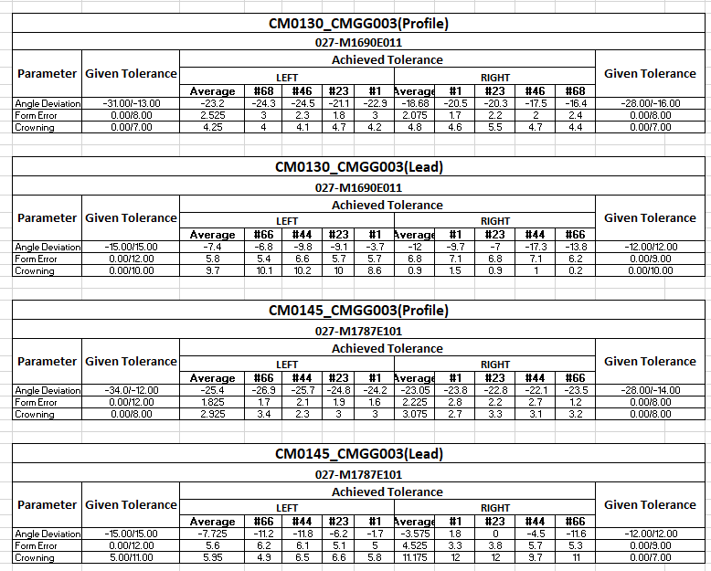

**Standard Deviation:**

The data's degree of variation or spread is depicted by the standard deviation. A data set with a higher standard deviation has a broader range around its mean. Typically, process data follows a normal distribution.

Standard Deviation, σ is given by:

**σ = √ {$\sum_{i=0}^{n}{{ [(x}_{i}-μ)^2] /n \} }$**

Using the above formula, standard deviations have been found out which are displayed below.

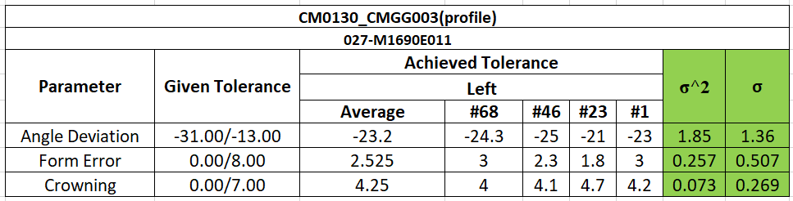

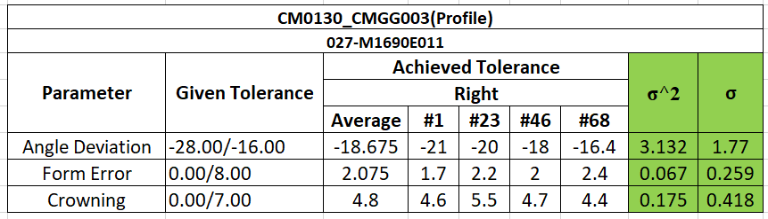

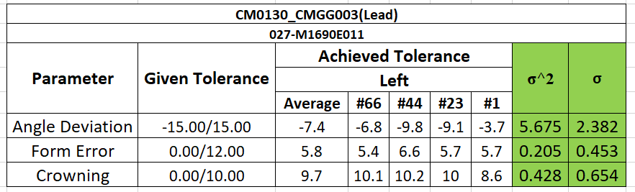

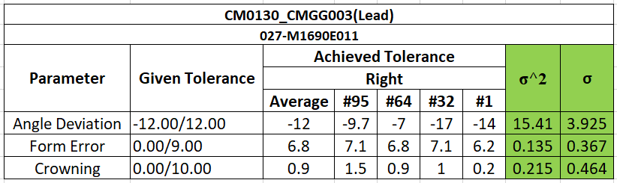

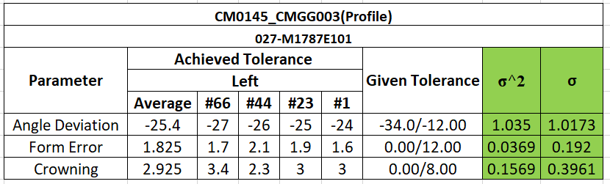

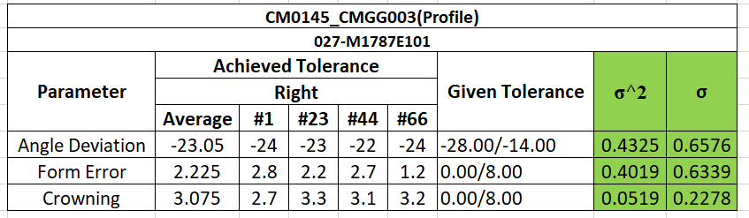

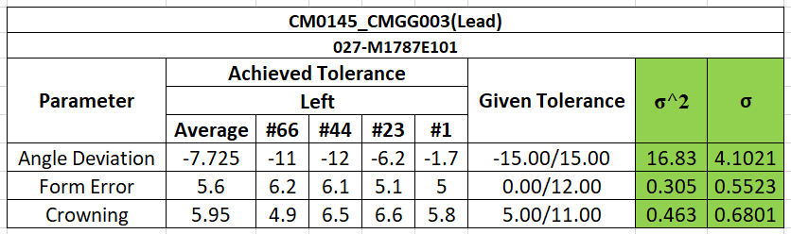

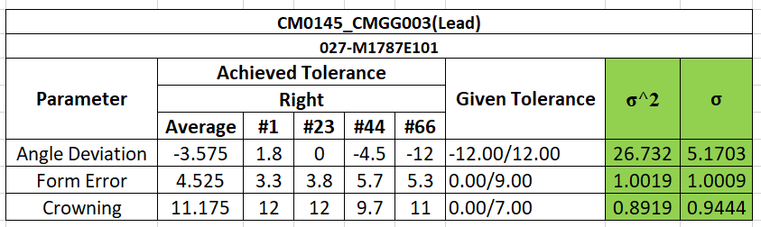

**Process Capability:**

The capability of a machine and its performance analysis can be done and understood by means of process capability analysis.

Higher the value of process capability, better the process will be.

Here, I have found out the process capability of the two machines using the above-mentioned formulae.

The results are attached here for the reference purposes.

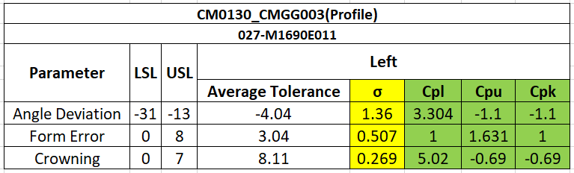

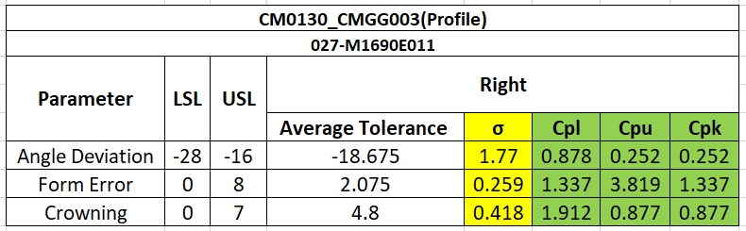

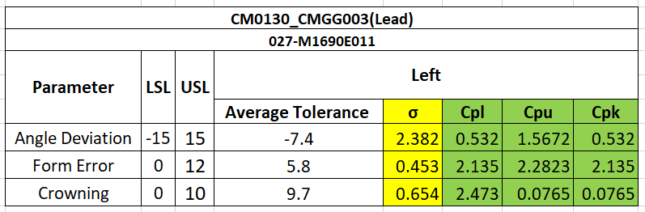

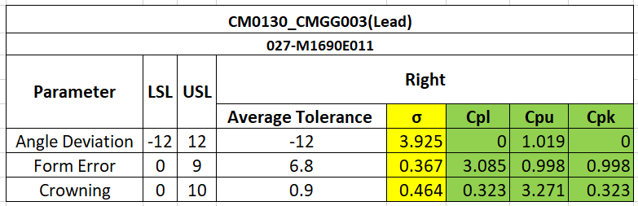

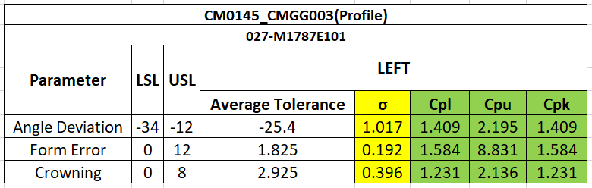

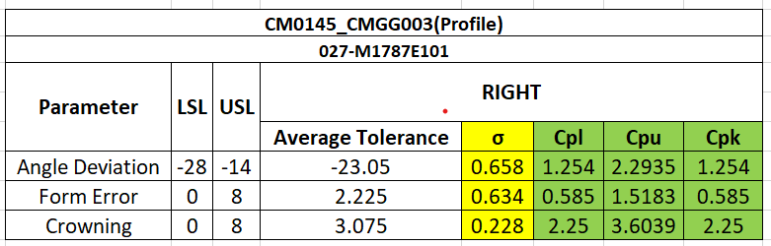

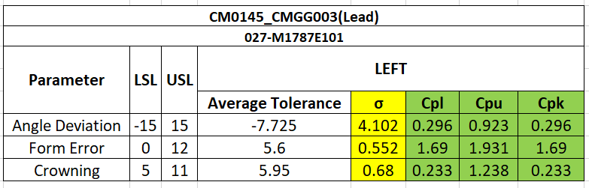

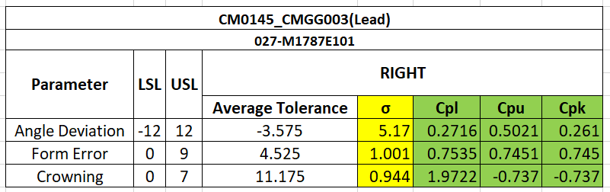

The minimum of these two values are considered as the process capability value. Instead of directly finding $C_{p}$, it is always better to do this way because the rejection with respect to this process can be either in the USL (Upper Specification Limit) part or the LSL (Lower Specification Limit) part.

Since we are not sure about the rejection nor the process is centered to the mean, it is always better to go by finding $C_{pl}$ and $C_{pu}$ and then go ahead with the $C_{pk}$ value.

Finally, the process capabilities of all the parameters with respect to all the specified machines are found and are displayed in the table given below.

**INFERENCE**

The Standard Deviations and the Process Capabilities of the given parameters have been found out and it is compiled together for better understanding in the table attached below.

**FOR LEFT FLANK:**

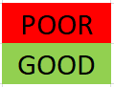

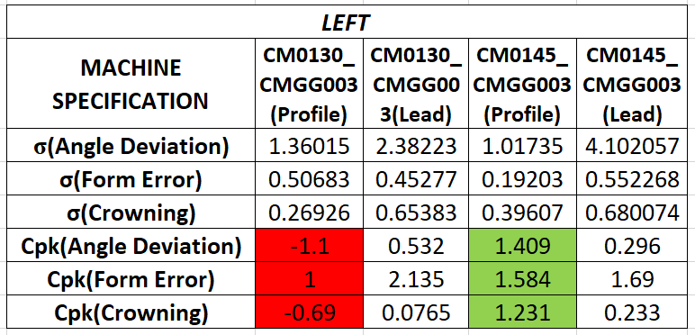

**FOR RIGHT FLANKS:**



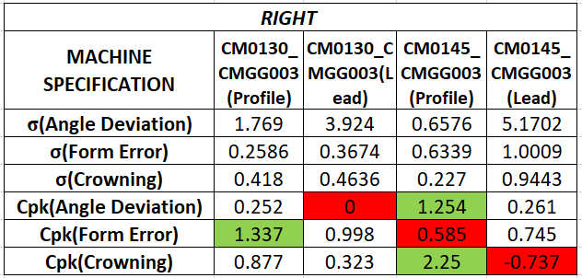

The cells which are marked with red are giving the least process capability values and those marked in green are giving the best process capability values out of the given machines.

As displayed in the table, we can see that almost 90% of the grinding processes have shown good process capability values in CMG0145_CMGG003 machine.

Poor performance is seen in CMG0130_CMGG003 machine. This machine has given minimum capability index values in almost all the parameters.

So, we can conclude that CMG0145_CMGG003 is performing better and the further grinding processes can be carried out in CMG0145_CMGG003 rather than going for CMG0130_CMGG003.